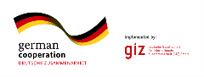

Instructions:
Fill out the form based on your analysis of the project design and context, listing stakeholders. Describe the role of communication for this project briefly.
Overall Project Objective
Intended Project Results
Project Activities
Project Activities | Project Activities
The Role of Communication to Enhance Project Outcome

